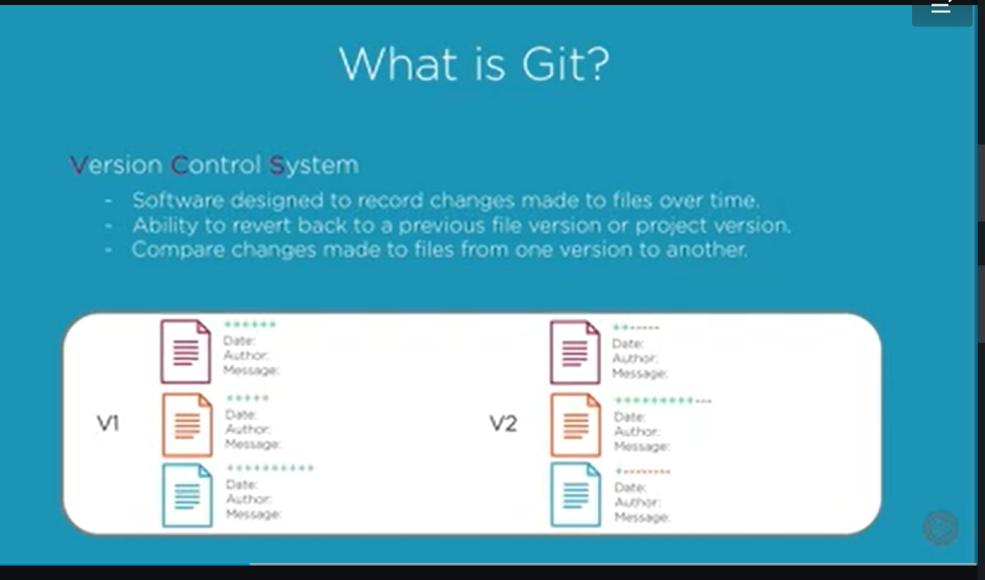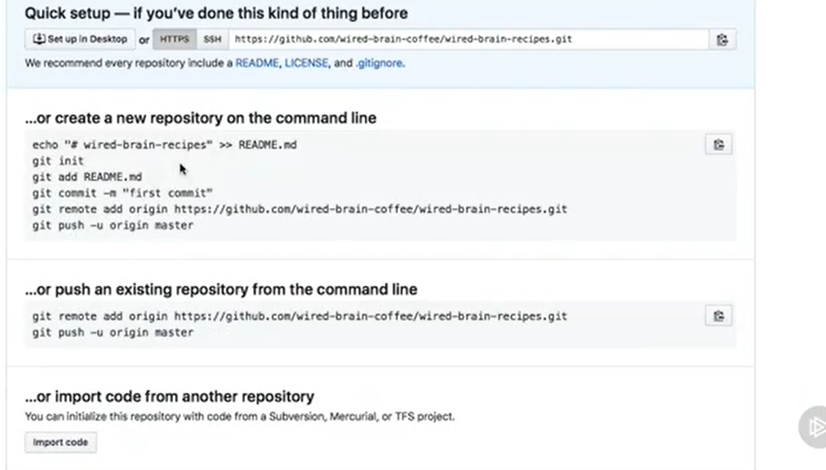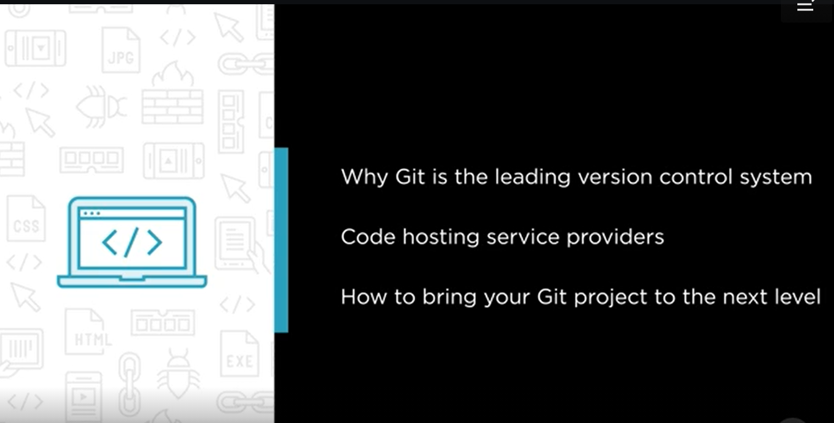

If you are working on big projects which contains multiple files so git will give you ability to handle entire projects. 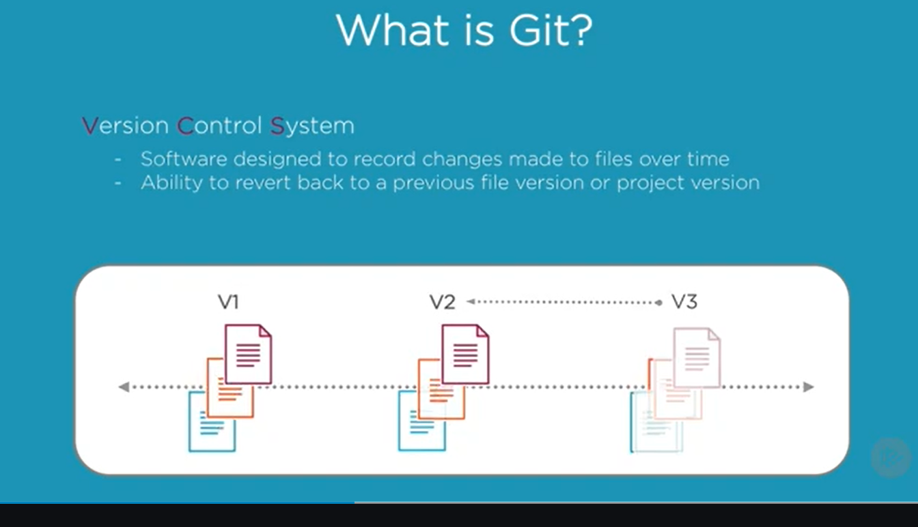 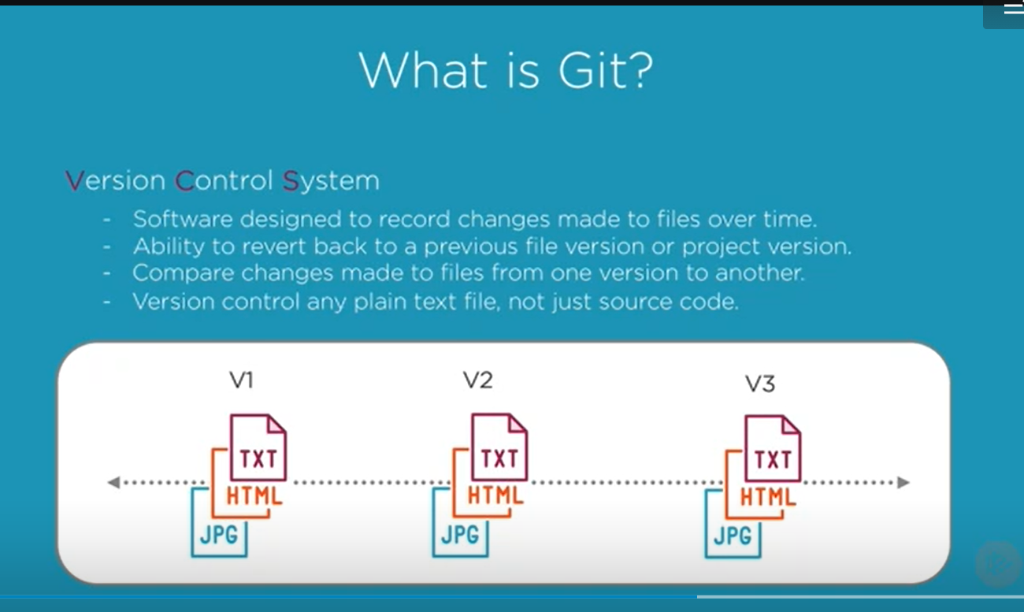

Version control gives you ability to explore new ideas with your projects. 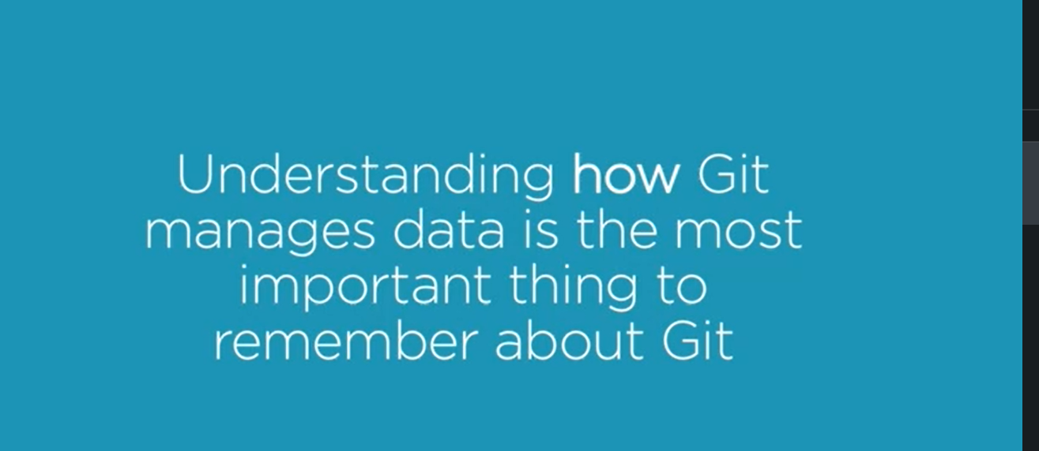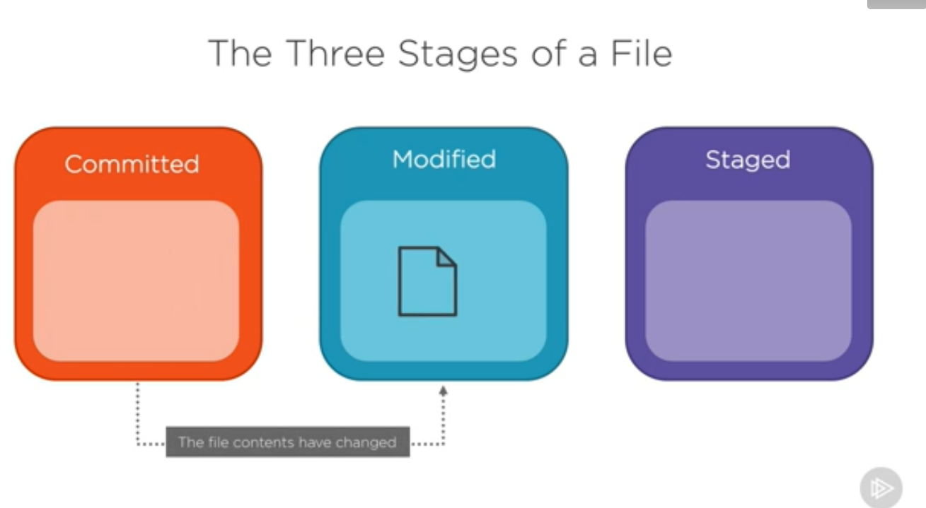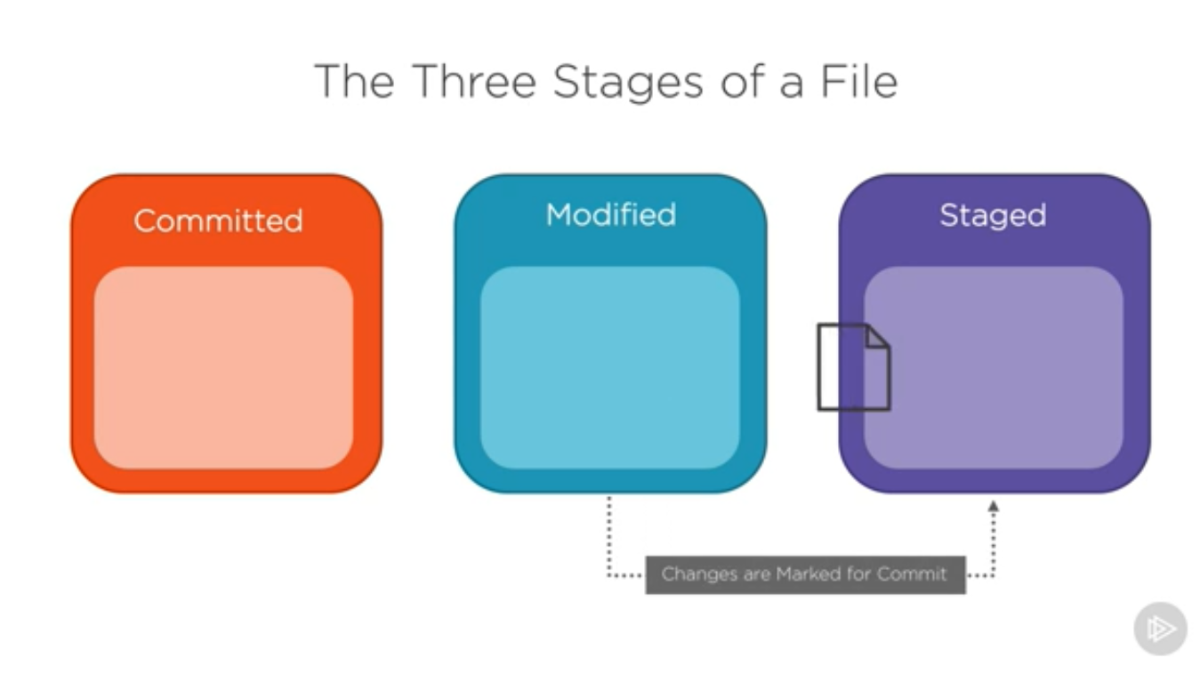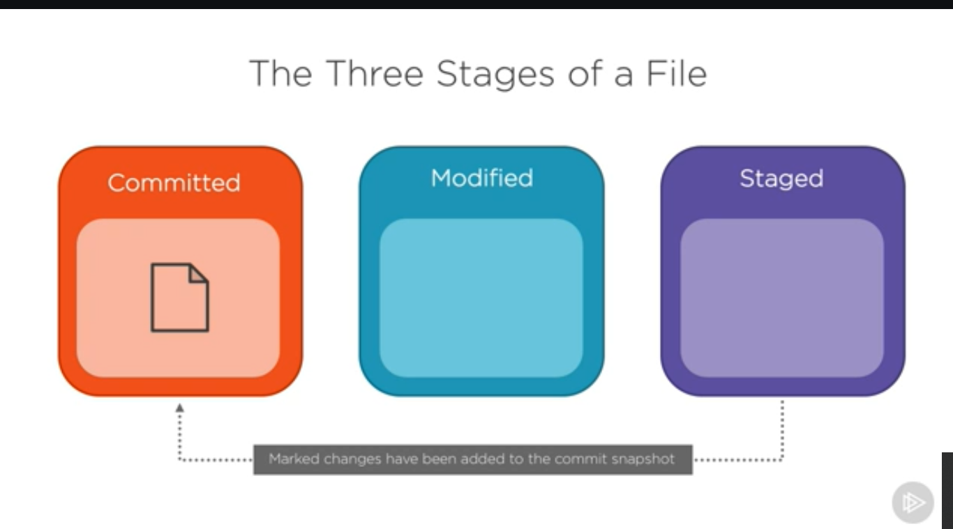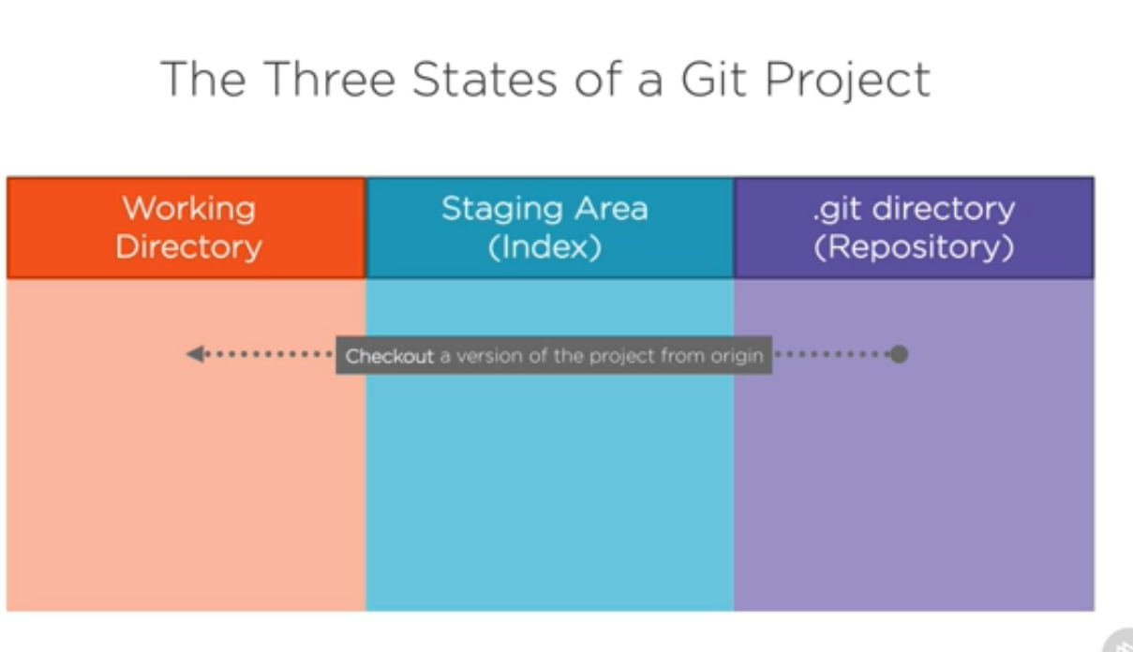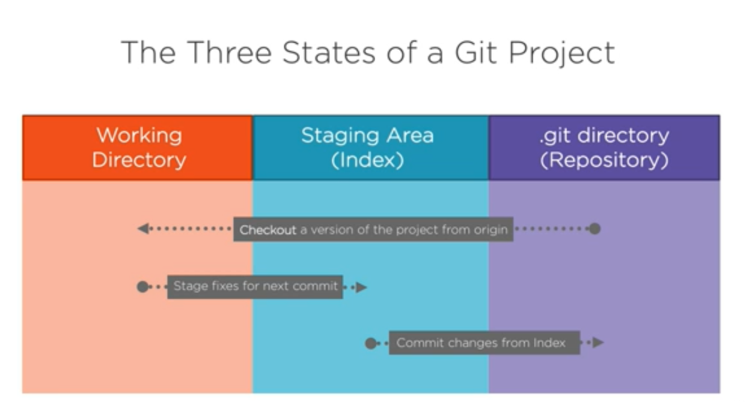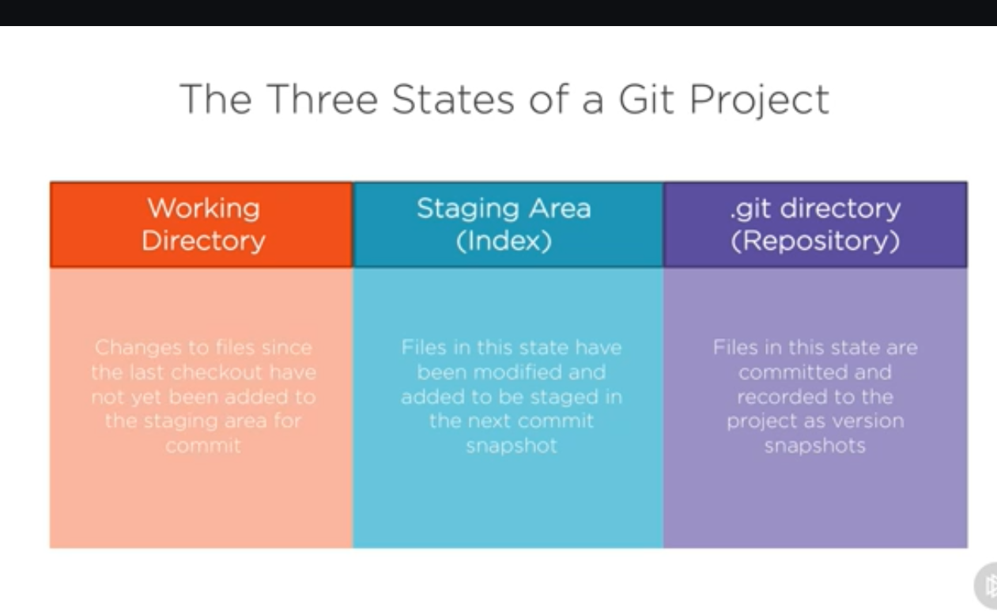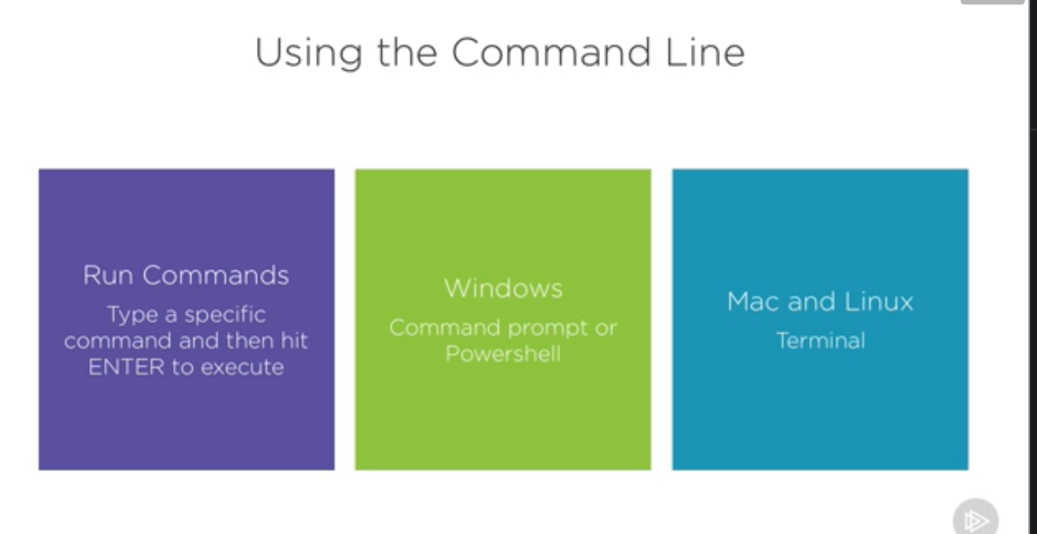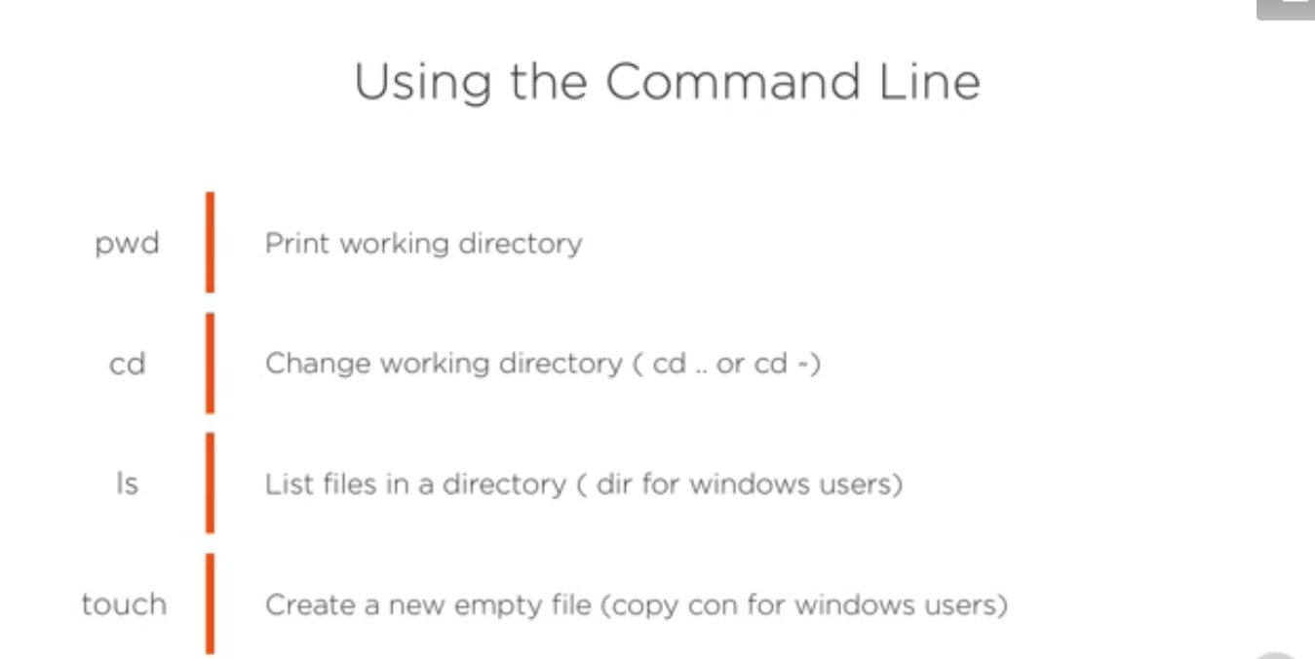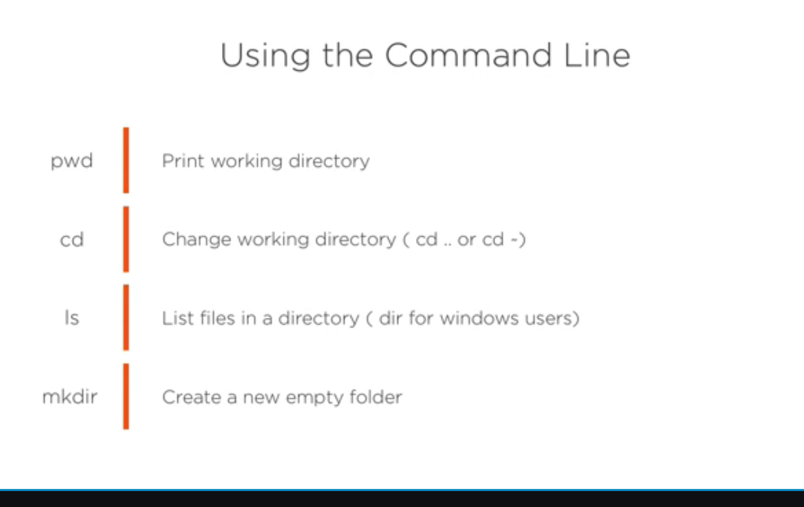

**For Checking Version of git**

Git --version

(Type git –version on command prompt for checking git version.)

**For Setting Username**

git config –global user.name “Sakshi Chaurasiya”

**For Setting Email**

git config –global user.email [sakshi.chaurasiya@naggaro.com](mailto:sakshi.chaurasiya@naggaro.com%20)

**For Checking Configuration Setting**

git config --list

**For Checking Specific Setting**

Ex. For checking user name

Git config user.name

**To know more about config section**

Git help config

**For initializing git repository**

Git init

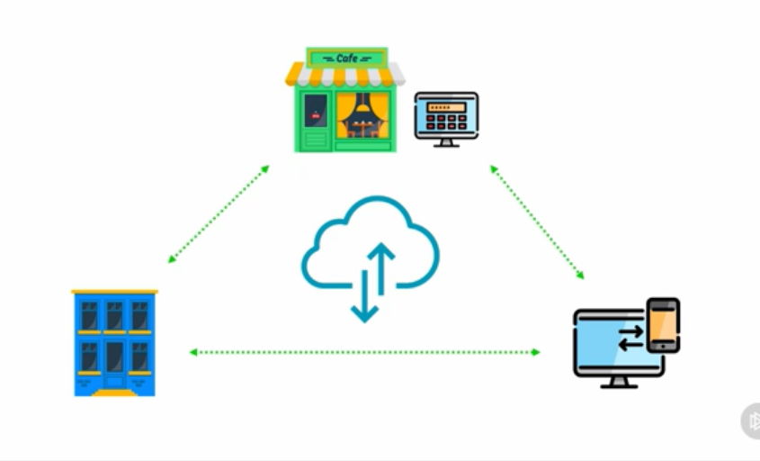

README is a quick and simple way for the collaborators to learn more about your repository.

**Commands for Adding Remote url**

Git remote add origin (then write SSH or HTTPS url from remote git)

Git push -u origin master

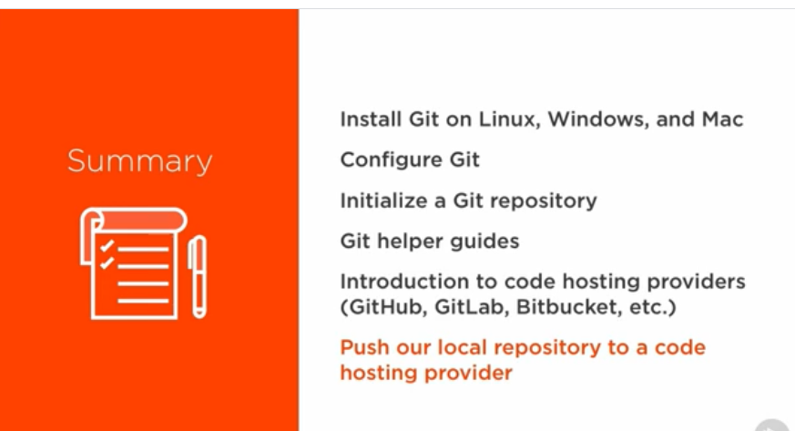

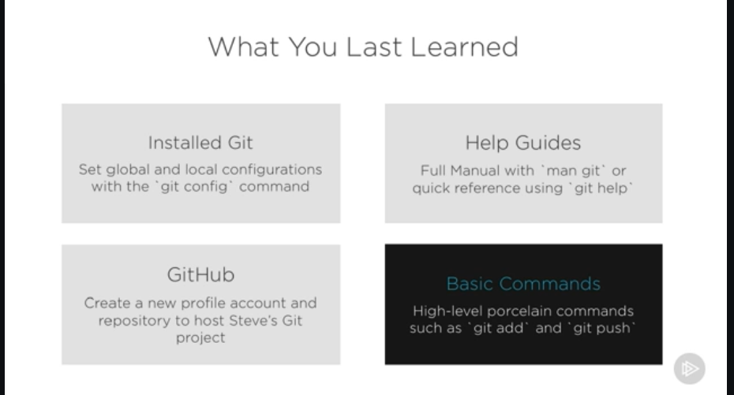

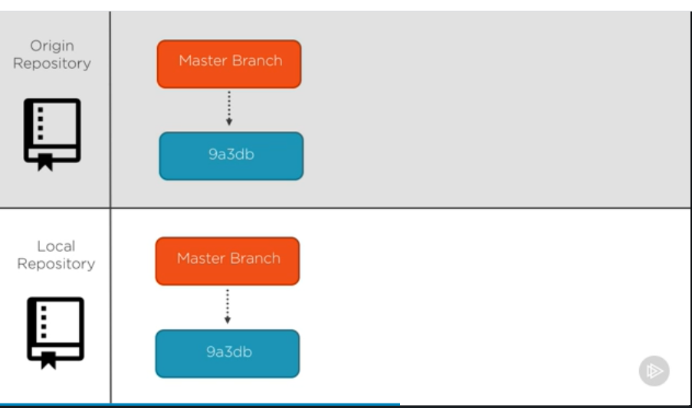

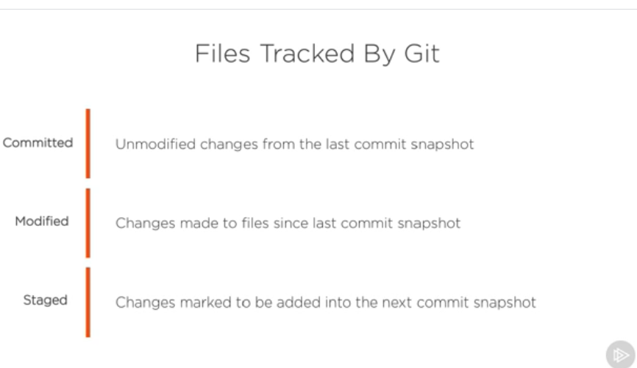

When we satisfy with our changes then we can add our file into staging area modified area for next committing .

**Command for opening file on visual studio by writing command on gitbash.**

Open -a atom abc.txt (abc.txt is file name )

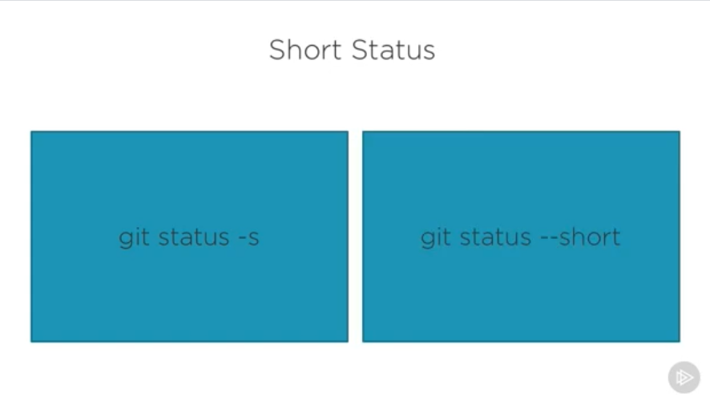

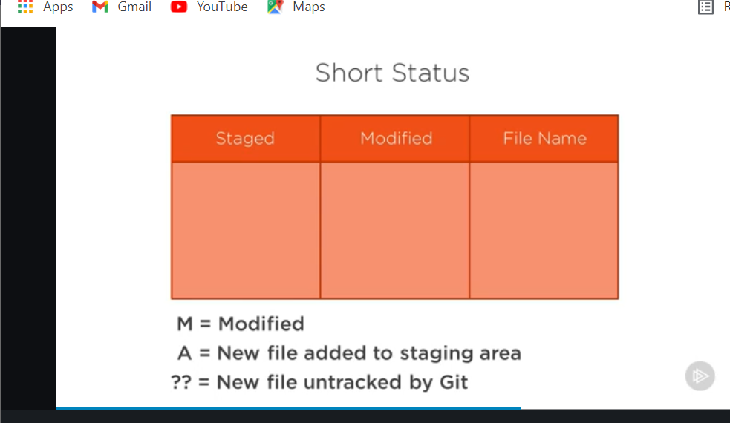

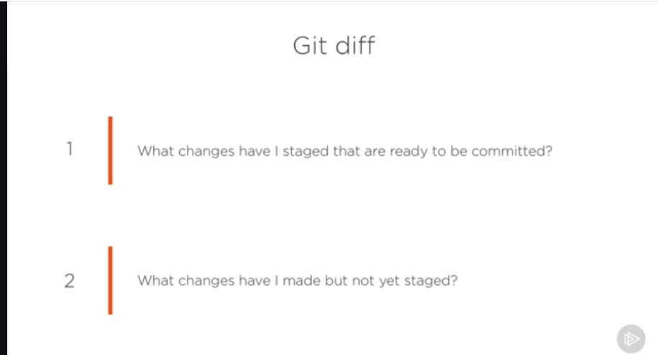

**Command for committing all files directly committed area from modified area with skipping staging area.**

Git commit -a -m “Message” (Message can be anything whatever we want)

Git log (it shows the history of previous all commits)

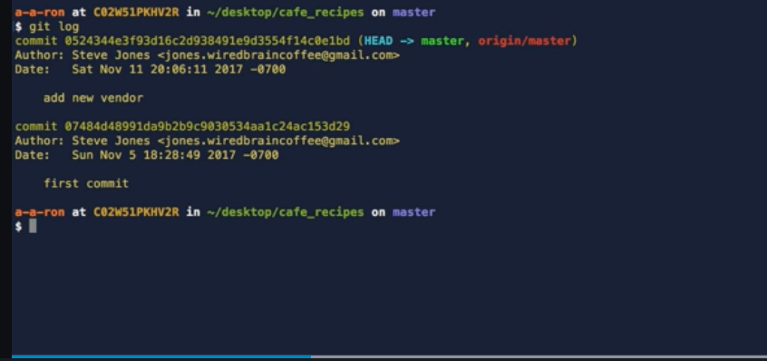

Git log -1 (It shows history of only last one commit)

Git log --oneline (Shows history of all commits in one line)

Git log –stat (History of previous all commits in more readable form)

Git rm abc.txt (for removing file from staging area (simply means that remove file from our project))

Git rm –cached abc.txt (Untracked file from staging area but not remove from project)

**Commands Related to branch**

Git branch master (For creating branch)

Git checkout -b new_branch(for creating new banch and switching from previous branch to this new branch)

Git commit -m “rename README.md remove abc.txt” (this command is used for renaming readme.md and removing abc.xt)

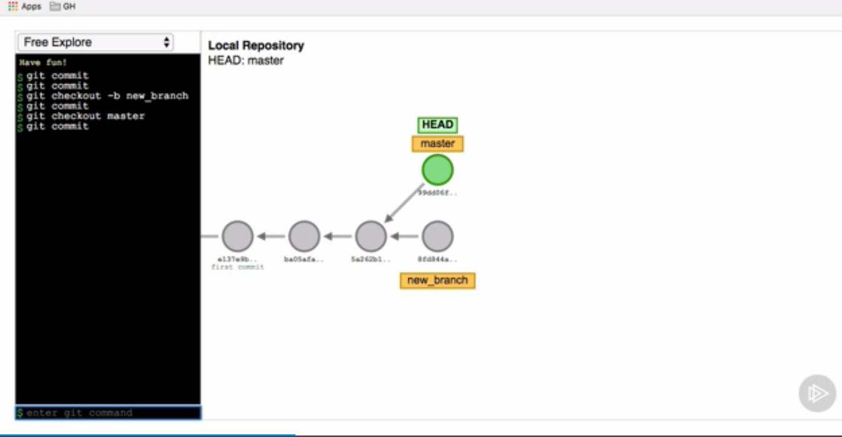

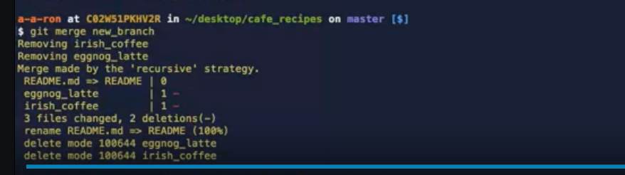

Git merge new_branch (merge new_branch into the master branch)

After merging will be done press (esc+:+w+q) on keyboard for come back into the previous state.

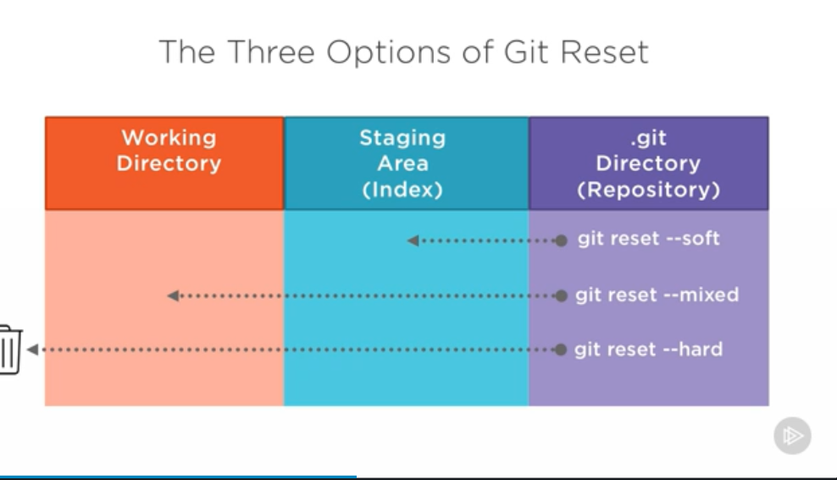

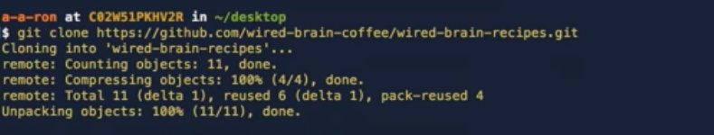

Git clone “URL of remote github” ( this command is used for cloning our project into other computer)

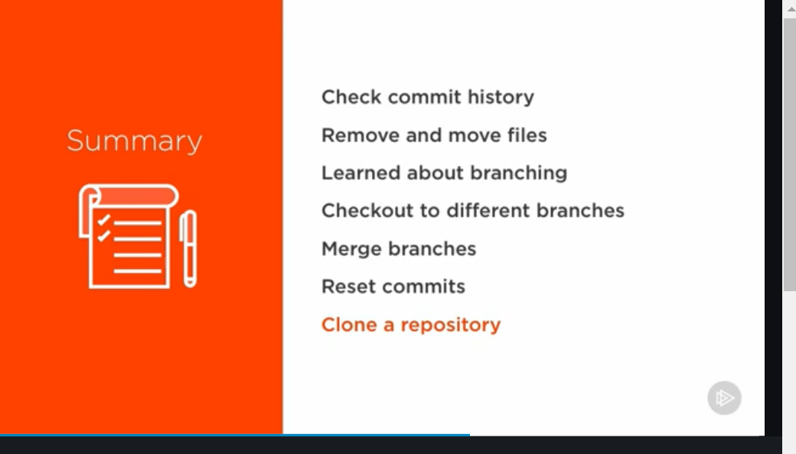

**MASTER ON GIT COURSE**

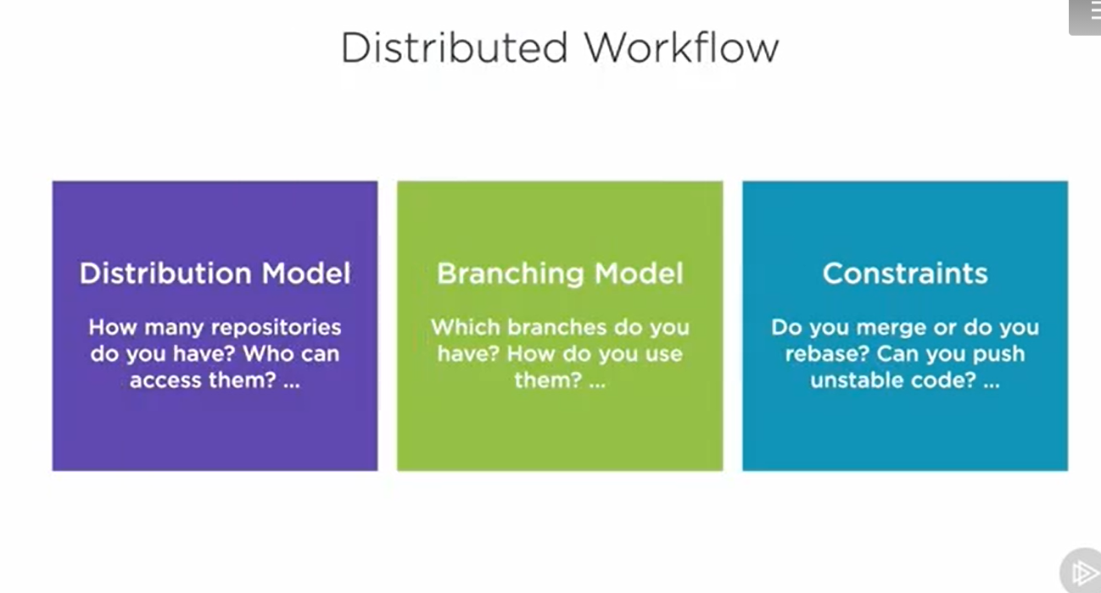

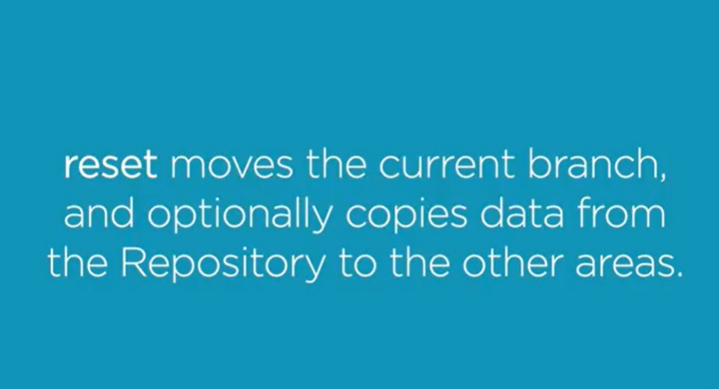

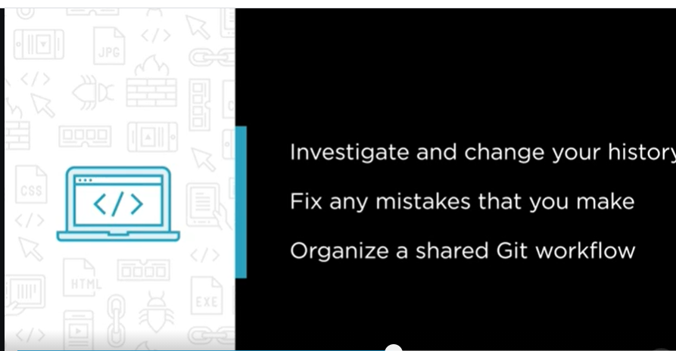

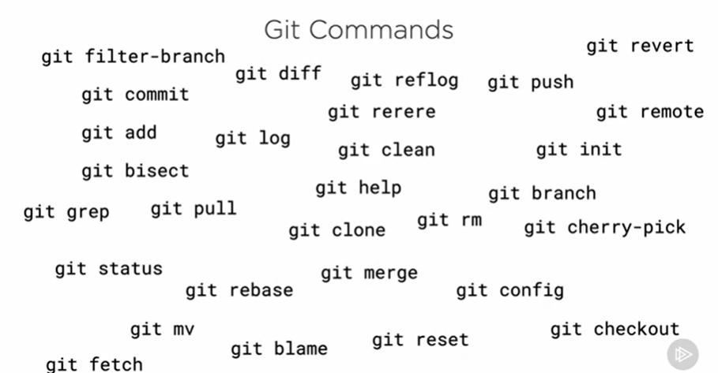

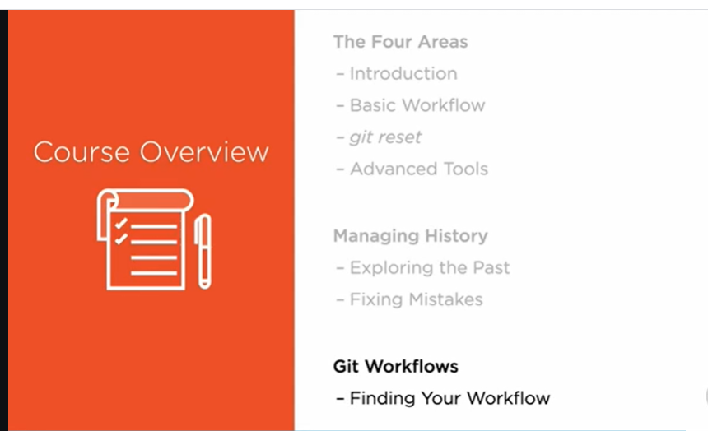

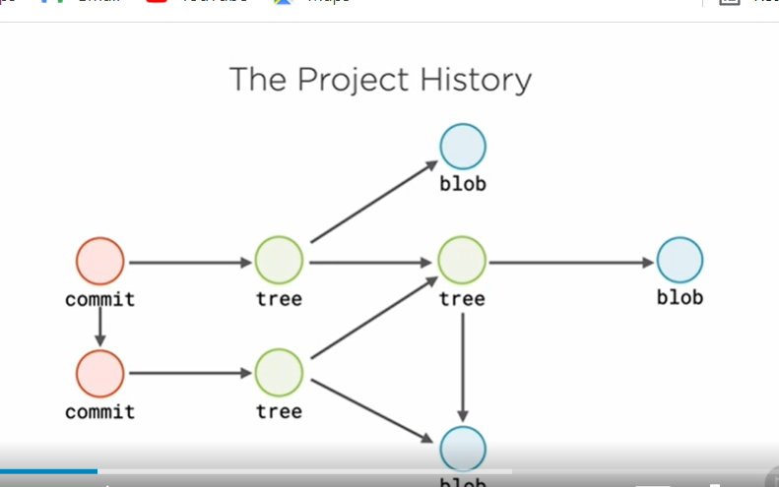

These objects are immutable they can be remove and create again but can’t be change.

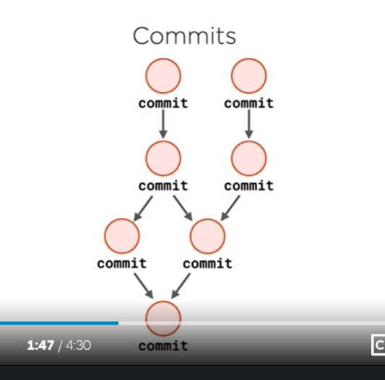

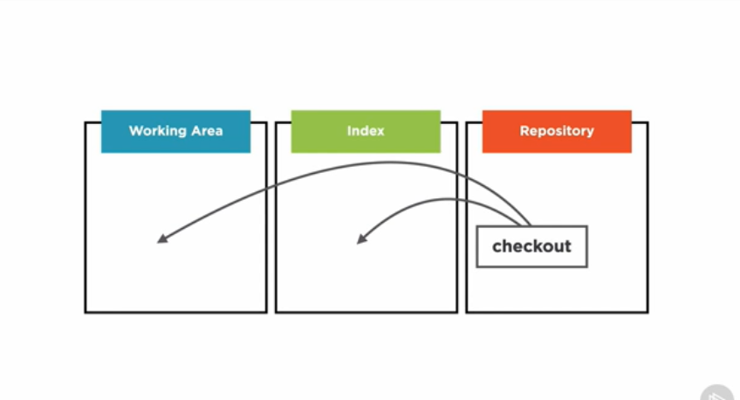

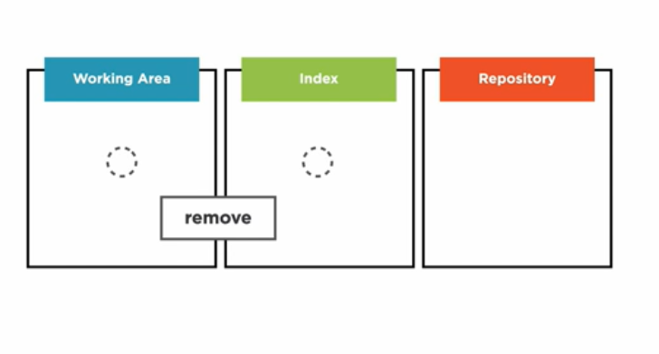

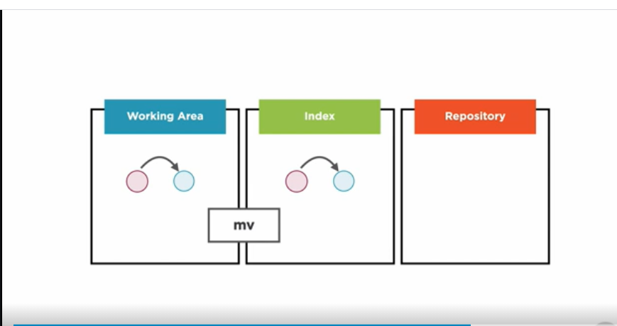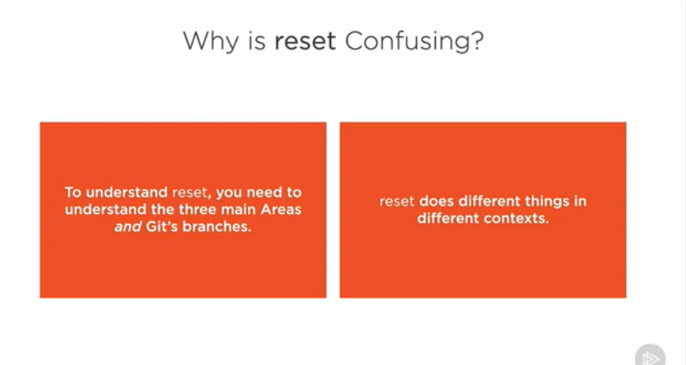

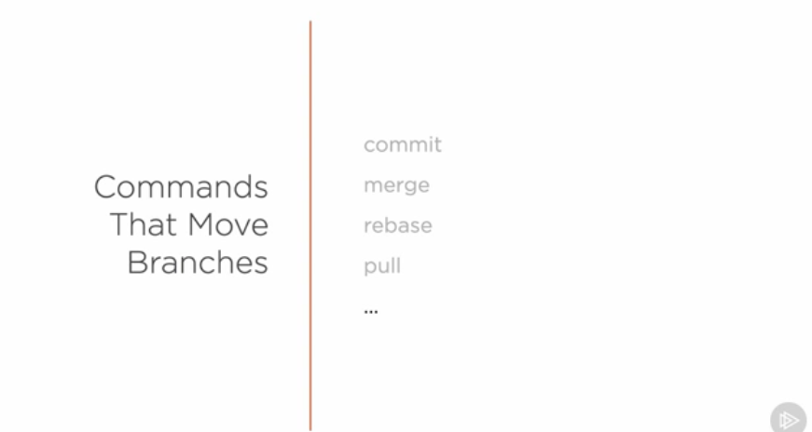

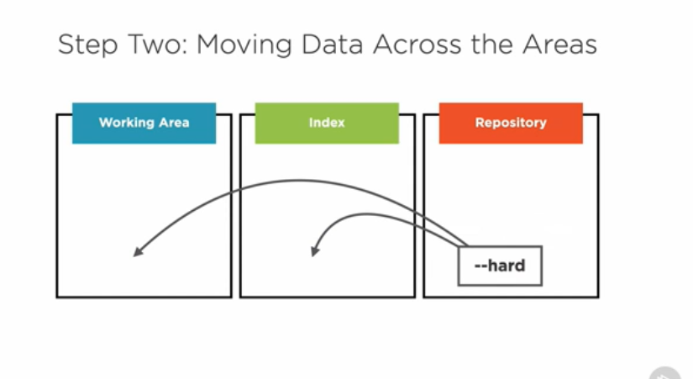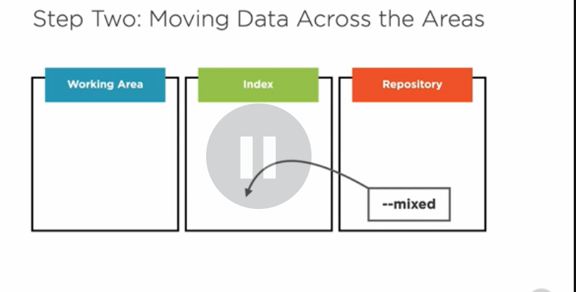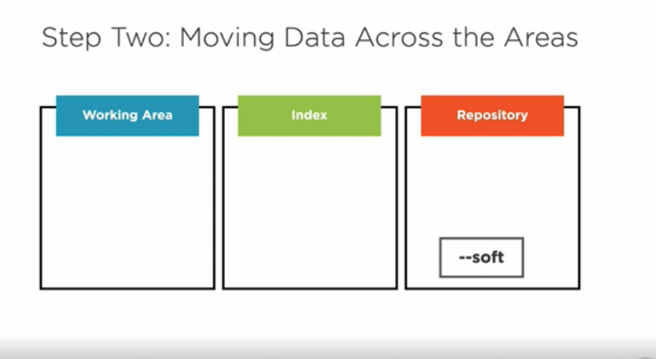

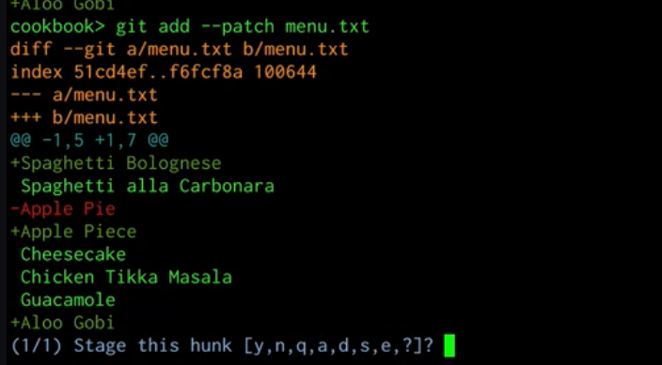

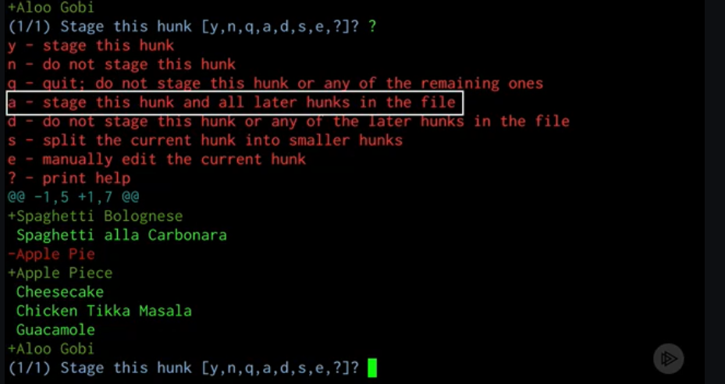

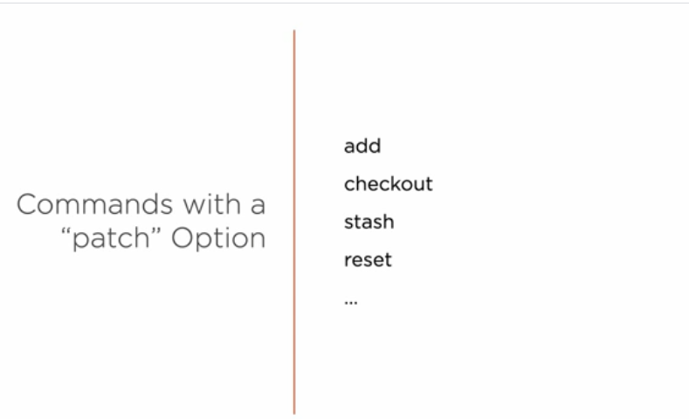

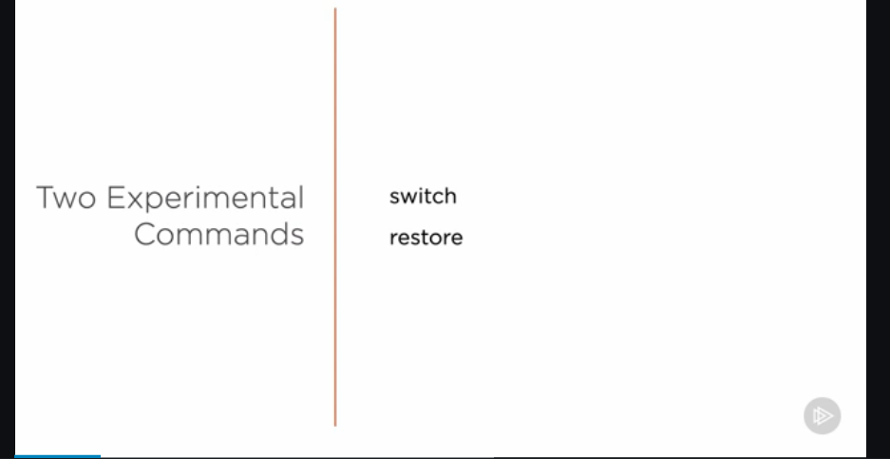

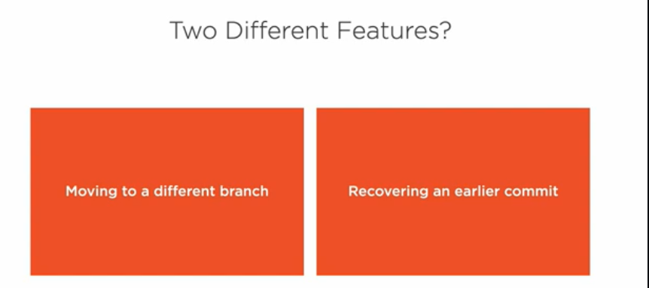

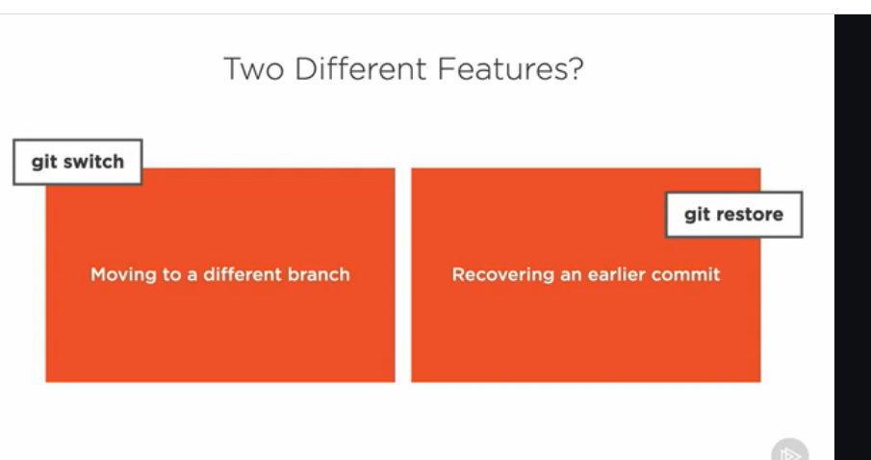

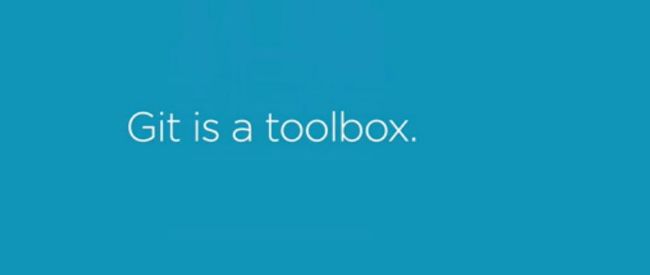

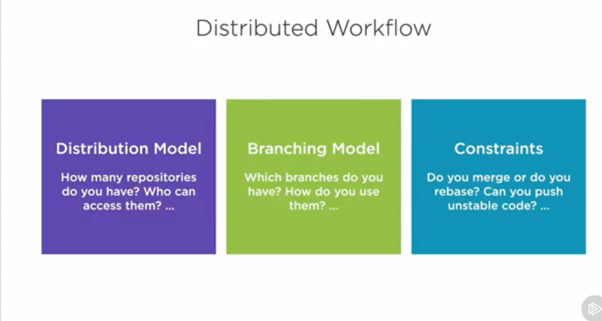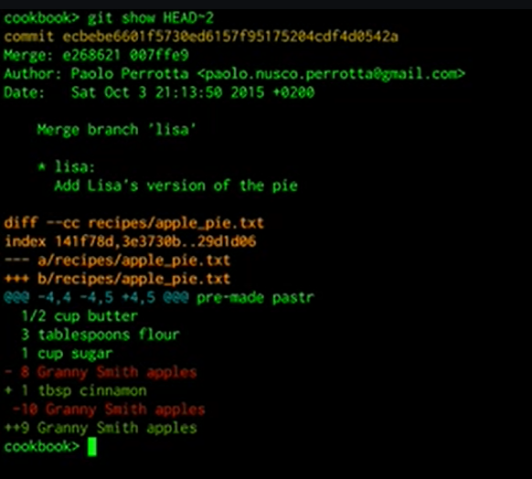

Suppose if I want to check 10th commit before current commit then I can use command like this-

Git show HEAD~10 (this command will work if you have only single parent but this will break if you have multiple parents).

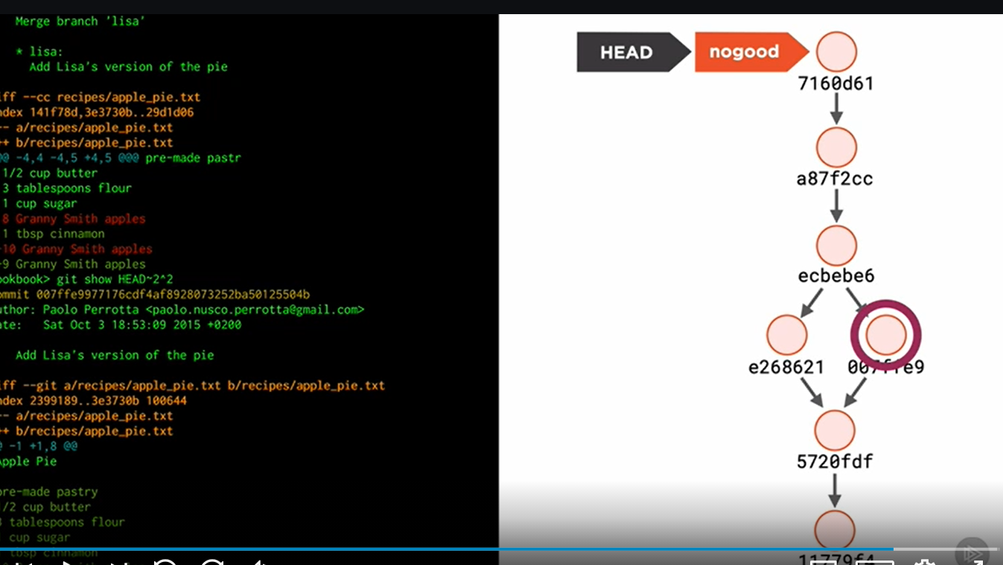

Suppose if you want second commits of second parent then you can use like this-

Git show HEAD~2^2.

**Bame Command**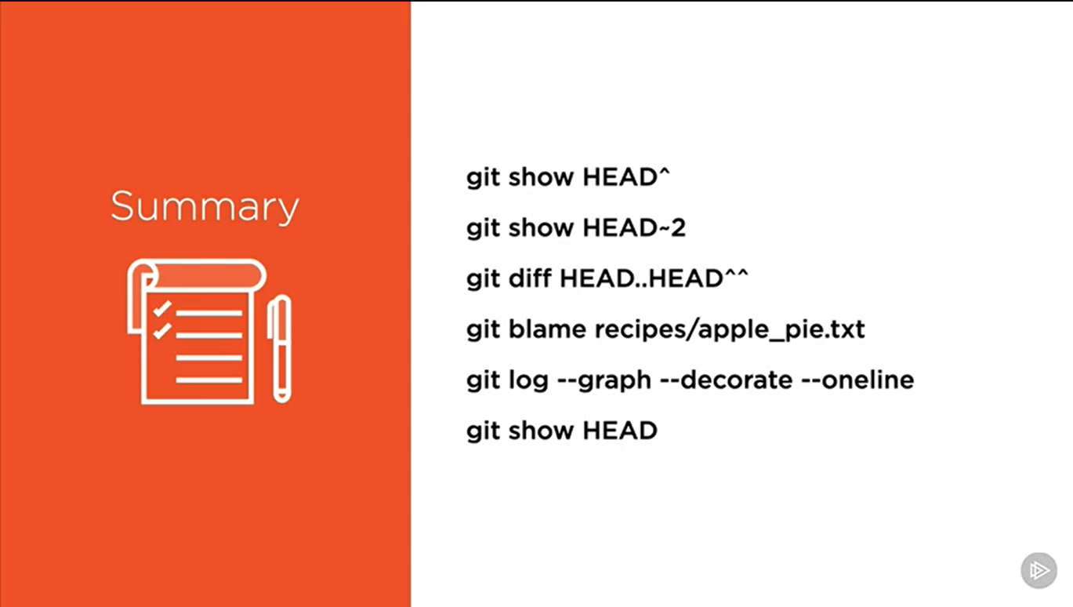

The **git blame command** is **used** to examine the contents of a file line by line and see when each line was last modified and who the author of the modifications was. The output format of **git blame** can be altered with various **command** line options.

**Ex-** git blame recipes/apple_pai.txt(this will examine all the information line by line of apple_pai.txt ) 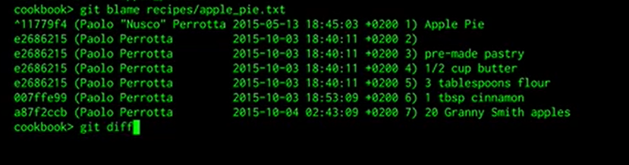

**Git Diff Command**

Git diff command is used to compare the contents of two areas like compare the contents of staging area and modified area. But it can also be use for comparing two commits we can see this through example –

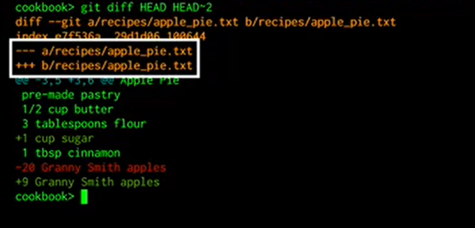

This is example of comparing current commit and 2nd commit before current commit.

Git diff HEAD HEAD~2

**Example for comparing two branches**

Git diff master abc (this command is use for comparing abc branch with master branch. This will shows all the changes made in abc and master branch) .

**Git Log**

Git log command use for project history

Ex- git log

**Git log patch command**

Git log –patch (this command is use for each commit in the log)

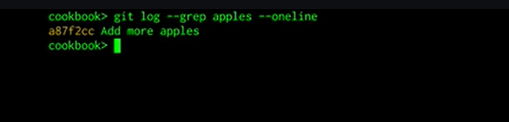Suppose if I want to see the commits that contains the only apples in the messages then I can use the above command.